USER, INSTALLATION & MAINTENANCE MANUAL
FOR
SIP SOFTWARE

Version No. 0.1



Electronics Corporation of India Ltd (ECIL)
Smart Governance & Solutions Division (SGSD)
ECIL Post, Hyderabad‐500062

Document Control
Review and Approvals
 |  |  | Designation |  | Name |  |  |  | Date |  | Signature
Prepared By |  |  | Trainee,  SGSD, ECIL |  | K Sri Chaitan |  |  |  | 27–Dec–2024
Reviewed By |  |  | DGM, SGSD, ECIL |  | K Sridhar |  |  |  | 29–Dec–2024
Approved By
Distribution
Copy No. |  | Holder’s Designation |  |  |  | Holder’s Name |  |  |  | Issue Date
1 |  | Officer (HR), CLDC, ECIL |  |  |  | Z Vidya
2
3
Amendment record
No | Date |  |  | Section(s) |  |  | Version No. | Description
1. | 07–Feb–2018 |  |  | All |  |  | 0.1 | Draft

Table of Contents
Document Control 2
1. Introduction 5
1.1 Purpose 5
1.2 Scope 5
1.3 Assumptions 5
1.4 Definition, Acronyms and Abbreviations 5
1.4.1 Definitions 5
1.4.2 Abbreviations and Acronyms 5
1.5 References 6
2. Resource Requirements 6
2.1 Hardware Requirements 6
2.2 Software Requirements 7
3. SIP Application Operation 8
3.1 User Types 8
3.2 User Login 8
3.3 GUI Operations 9
3.3.1 SIP operator Home Page GUI (Main Screen) 9
3.3.2 Operator Side Bar 10
3.3.3 Home Button 11
3.3.4 <User> Menu 11
3.3.4.1 Logout 11
3.3.4.2 Change password 12
3.3.5 SIP Admin Homepage GUI 13
3.3.6 Admin Sidebar 14
3.4 Operator Tasks(Sidebar links) 15
3.4.1 Mentor Acceptance Form 15
3.4.2 Joining Form 17
3.4.3 No Dues Form 19
3.4.4 Generate Certificate 20
3.5 Admin Tasks(Sidebar links) 22
3.5.1 Create user 22
3.5.2 Operator Details 22
3.5.3 Fetch student internship data 23
3.5.4 Fetch mentor acceptance forms 23
3.5.5 Certificates not collected 24
3.5.6 Internship Verification 24

4. SIP Installation 25
4.1 Contents of SIP 25
4.2 Installation of the Required Files 25
4.3 Setting up the Database 25
4.4 Running SIP Software 26

Introduction
The SIP Software is a specialized database application for managing student internship details at ECIL. It securely stores joining forms, mentor acceptance forms, and facilitates the generation of certificates and due forms. Designed for simplicity and reliability, it ensures efficient data handling and documentation.

Purpose
The SIP Software is designed to centralize and streamline the storage of essential internship documents, such as joining forms and mentor acceptance forms. It also facilitates the generation of certificates and dues forms for student interns at ECIL.

Scope
The software serves as a secure, user-friendly database for document storage and form generation.

Assumptions
All necessary user manuals for devices or software not included within the scope of the SIP Software will be provided by their respective vendors. This includes any third-party tools or systems required to facilitate the operation and management of student internship data.

Definition, Acronyms and Abbreviations

Definitions

SIP | Student Internship Portal Software Web Application
User | Can be Admin or Operator user
User System | Client PC from which SIP software is accessed through browser

Abbreviations and Acronyms

SIP | Student Internship Portal
SGSD
CLDC
ASCII | American Standard Code for Information Interchange
ECIL | Electronics Corporation of India Limited
GUI | Graphical User Interface
M &C | Monitoring & Control
NMS | Network Management system
MIB | Management Information Base
NTP | Network Time Protocol
URD | User Requirements Document

References

S.No. | Document | Description
1. | Software Requirements Specification | The SRS document submitted by ECIL.

Resource Requirements
The following resources are required for the operation of SIP Software.

Hardware Requirements

The SIP Software requires a system with the following minimum specifications and a stable Wi-Fi connection to ensure smooth operation:
- Server System:
- Intel (R) Core i5 or higher processor.
- 8GB DDR4 RAM or higher.
- 1TB HDD or SSD for storage.
- RJ-45 Ethernet port or built-in Wi-Fi.
- USB Ports, VGA/HDMI support.
- Standard keyboard and mouse.

- Operating System:
- Windows 10 or higher, or Linux-based OS (Ubuntu, Fedora, etc.).
- Display:
- 23” or larger monitor with Full HD resolution.
- Networking:
- Stable Wi-Fi connection with at least 10 Mbps speed.

These requirements ensure reliable performance and accessibility for managing internship-related data efficiently.

Device Requirements

Resource | Qty (Nos) | No. of Ethernet Cables Required
 | 1 | 1
  Workstation (Server System)
 | 1 | 1
  Network Router or Switch
 | 1 | Nil
  Printer (for forms/certificates)
 | 1 | Nil
  Wi-Fi Access Point

Software Requirements

Server Software Requirements

Software | Description | Qty
SIP Software |  | 1
  SIP Software for managing student internship data
Operating System |  | 1
  Linux-based OS (RHEL 7.0 Server Edition or compatible)
Database |  | 1
  MySQL Database for data storage
Web Server |  | 1
  Flask 2.2 Server for web application hosting

Client PC Software Requirements

Software | Description | Qty
Latest Web Browser | Internet Explorer 8.0 or Google Chrome 45.0 or Mozilla Fire Fox 45.0 | 1
Operating System | Any Operating System  (Windows or Linux) | 1

SIP Application Operation

User Types

User Types

Admin User

Operator User

Operator User
- The purpose of the Operator User is to facilitate the completion of the student joining form and mentor acceptance form, ensure accurate information collection, and generate the no dues form and certificates for the students upon completion of their internship.

Admin User
- The purpose of the Admin User is to manage operator accounts, including creating new operators and admins. Additionally, the admin has exclusive access to view and manage the database, ensuring proper oversight and control over the system's operations.

User Login
- To Login to the SIP application, a user with either Admin or Operator rights need to be registered/created by the default “Admin user” who is created before the project is deployed.

Below figure shows the Login Screen to access the application, which is visible to the user on the right side of the screen.
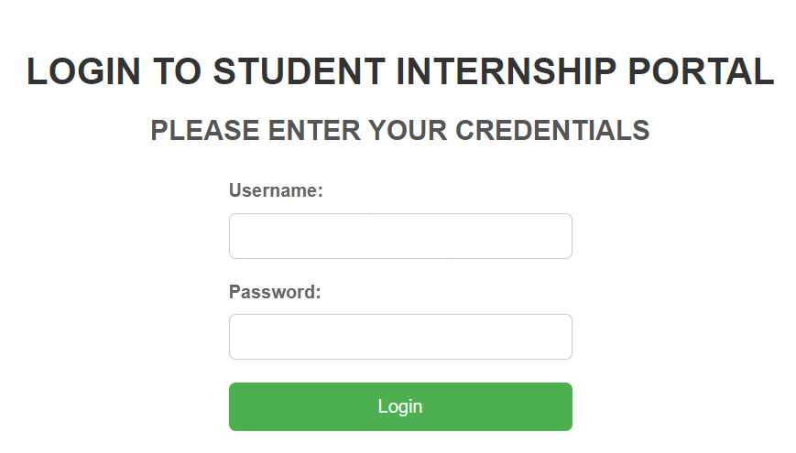

- User has to follow the following steps to access the application.

- User should enter valid user name in “Username” text box
- User should enter valid password in “Password” text box
- After entering the required fields user has to click on “Login” in button.
- The system will navigate to home page of the SIP application.

GUI Operations

SIP operator Home Page GUI (Main Screen)

After operator user logs into the system, the Home Page which is shown below is displayed.
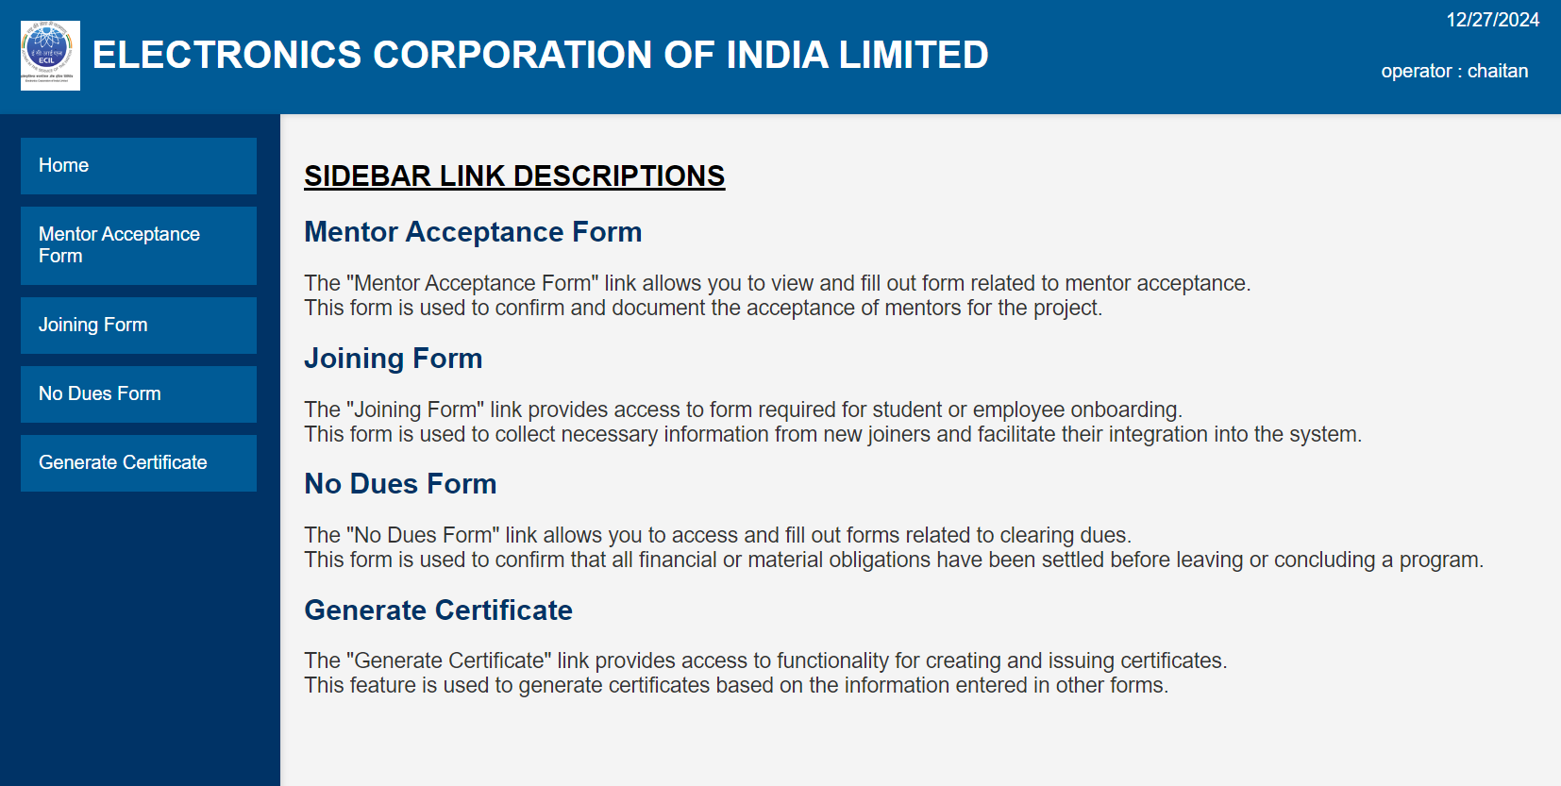

Operator Side Bar
Figure of the operator Side Bar is shown below.
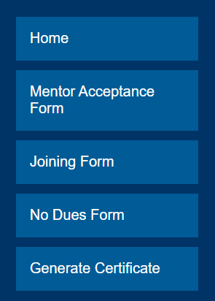

- The Side bar consists of following menus:
  - Home button named “Home”
  - “Mentor Acceptance form” for the student to fill the form before assigning him a mentor
  - “Joining form” for the student to fill the form before joining for the internship
  - “No Dues form” for the student to fill the form upon completion of the internship
  - “Generate certificate” to generate the completion certificate of the student.

Home Button


- Whenever user wants to go to home page from any other page, click on <Home> which is located at the top right corner of the application.

<User> Menu
- The menu is accessible by clicking on the user's username, located at the top-right corner of the screen, next to the date and the user's type. Figure of the Menu is shown below.
- Whenever User clicks on the Menu, the following submenu will be displayed.
  - Logout
  - Change Password
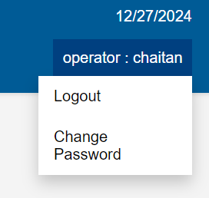

Logout

The purpose of the Logout Button is to securely log the user out of the system, ensuring that their session is terminated and preventing unauthorized access to sensitive information after they have finished using the application.
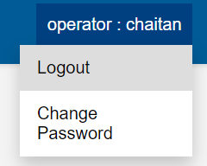

- To logout from the present screen, click on <logout> sub menu of <User> dropdown menu, as shown in the above figure.
- The below screen is displayed when the User is logged out from the application. This is the Login screen which can be used if the User wants to Login again.
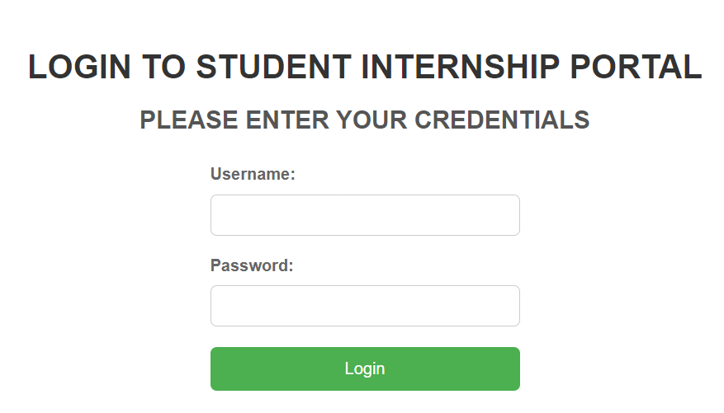

Change Password
The purpose of the Change Password submenu is to allow users to update their login credentials, ensuring the security of their account by providing a way to maintain confidentiality and protect against unauthorized access.

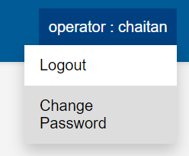

- To access this submenu click on <change password> sub menu of <User> dropdown menu, as shown in the above figure.

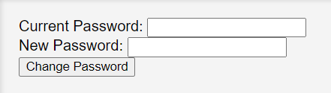

- Enter the old password and the new password of the current user.
- After filling all fields, click on ‘Change Password’ button, then user password will be successfully changed and “password updated successfully” message is displayed. This is shown in the figure below.
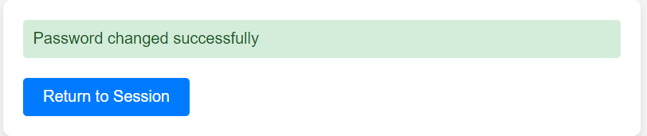
- If Password could not be changed for any reason, the corresponding error message is displayed.
- Click the “Return to session” button to go back to the home page.

SIP Admin Home Page GUI

After Admin user logs into the system, the Home Page which is shown below is displayed.

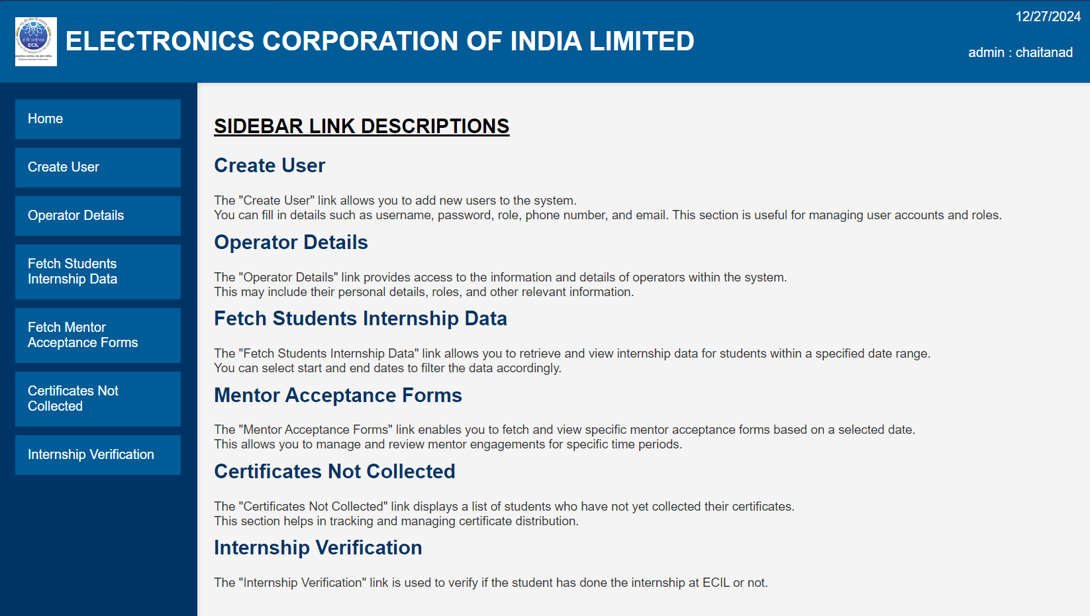

Admin Side Bar

The figure of the Admin side bar is shown below.

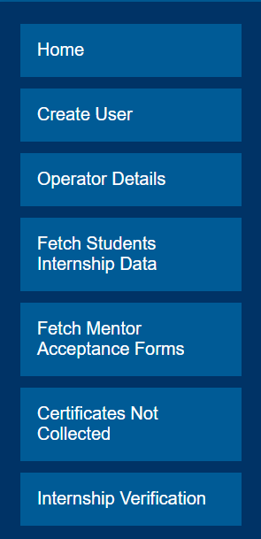

- The Side bar consists of following menus:
  - Home button named “Home”
  - “Create user” for the admin to create a new user
  - “Operator Details” for the admin to view the operators in the database
  - “Fetch Student internship Data” for the admin to view the students who did/currently doing internship.
  - “Fetch Mentor acceptance Forms” for the admin to view and download the mentor acceptance forms
  - “Certificates not collected” for the admin to view the details of the students who are yet to collect their certificates.
  - “Internship verification” for the admin to check a particular student has internship at ECIL or not.

Operator Tasks (Sidebar Links)

Mentor Acceptance Form
- The Operator is responsible for ensuring that the student completes the Mentor Acceptance Form. Access to this form is available through the sidebar on the operator's homepage, under the section labelled "Mentor Acceptance Form."
- When clicked on the “Mentor Acceptance form” section the following window is displayed.
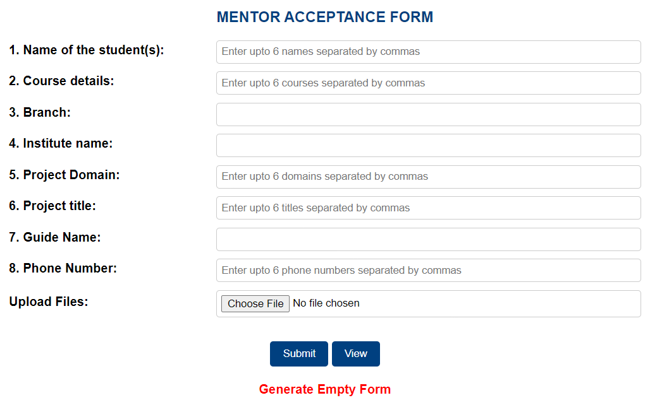

- The Mentor Acceptance Form allows the operator to enter the names of up to six students from the same branch, with their details separated by commas. All students listed will be assigned to a specific mentor or guide, ensuring they are from the same branch and institute. Additionally, there is an option to upload a file, enabling the operator to upload an offline-filled form for confirmation purposes.
- Once the details are filled the “Submit” button can be clicked to successfully store the details in the database. This will redirect the operator to the home page with success message “Student details submitted Successfully” at the top. In case of any error the error message is also displayed. The below figure shows the displayed success message.

- The “View” button is to be used when the operator want to fetch the mentor acceptance form of a particular student. When the “view” button is clicked the following window is shown.
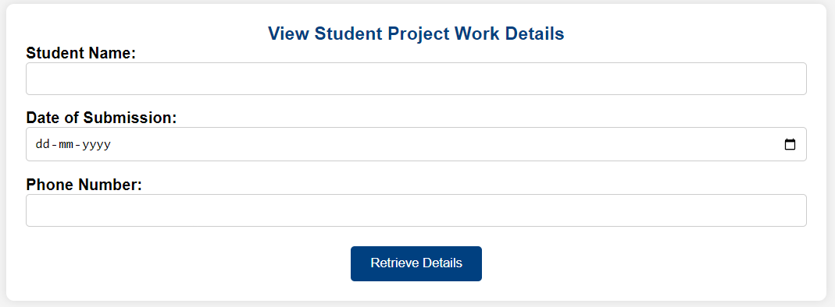
After entering the student name, date of submission of the student’s mentor acceptance form and the phone number of the student, the “retrive details” button is to be clicked in order the fetch the mentor accptance form of the student.
If the student exists in the database then his/her form is fetched or else an empty form is shown. Operator also has the option to print or edit the form fetched using the <print> and <edit> button respectively as shown in the figure below.

- Operator also has the functionality to generate an empty for for offline submission which can be done by clicking on the <Generate Empty Form> link as shown in the figure below.

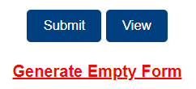
- Clicking on this link will redirect the operator to a new window with an empty form, which he can later print using the <print> button at the bottom.

Joining Form
- The Operator is responsible for ensuring that the student completes the Joining Form. Access to this form is available through the sidebar on the operator's homepage, under the section labelled "Joining Form."
- When clicked on the “Joining form” section the following joining form is displayed.
(The image of the joining form is split into 2 halves)
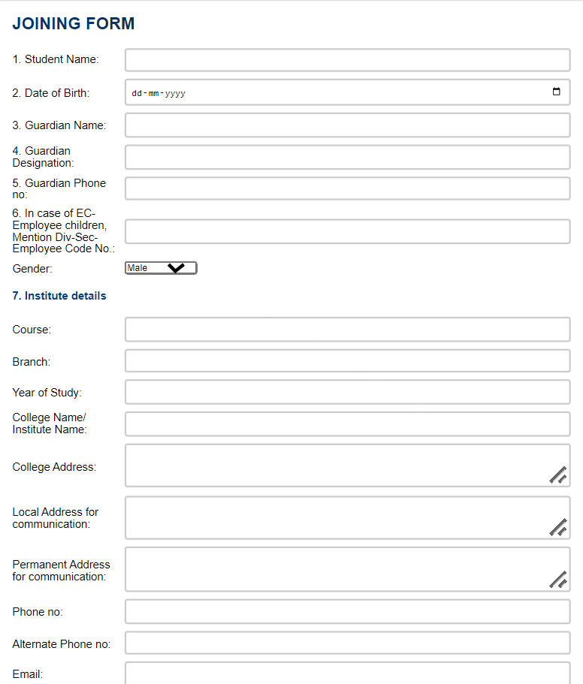
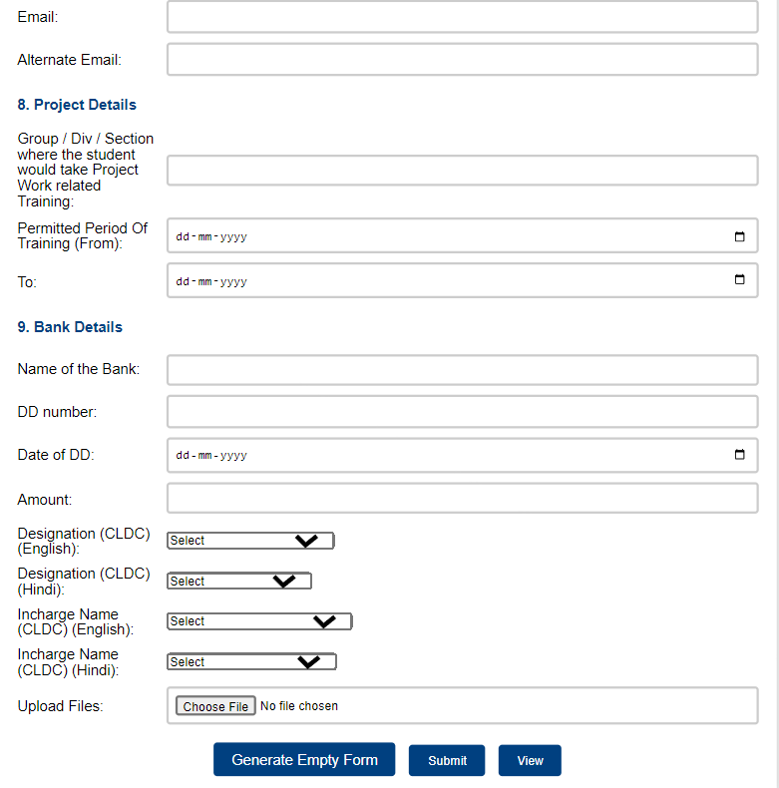
- There is an option to upload a file, enabling the operator to upload an offline-filled form for confirmation purposes.

- Once the details are filled the “Submit” button can be clicked to successfully store the details in the database. This will redirect the operator to the home page with success message “Student details submitted Successfully” at the top. In case of any error the error message is also displayed. The below figure shows the displayed success message.

- The “View” button is to be used when the operator want to fetch the mentor acceptance form of a particular student. When the “view” button is clicked the following window is shown.
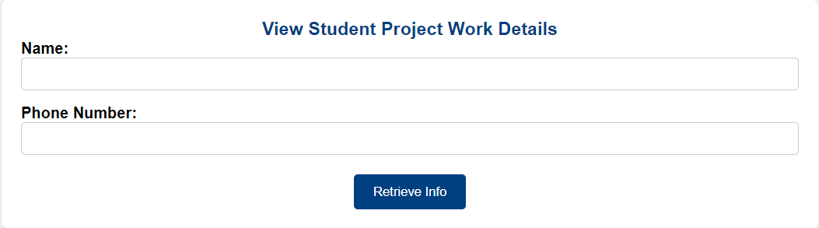
After entering the student name and the phone number of the student, the “retrieve info” button is to be clicked in order to fetch the joining form of the student.
If the student exists in the database then his/her form is fetched or else the page is redirected to the home page displaying an error message “Student not found” as shown below

Operator also has the option to print or edit the form fetched using the <print> and <edit> button respectively as shown in the figure below.


- Operator also has the functionality to generate an empty for for offline submissions which can be done by clicking on the <Generate Empty Form> button as shown in the figure below.

- Clicking on this link will redirect the operator to a new window with an empty form, which he can later print using the <print> button at the bottom.

No Dues Form
- After the completion of the training period the Operator is responsible for ensuring that the student completes the No Dues Form so that he can receive his certificate. Access to this form is available through the sidebar on the operator's homepage, under the section labelled "No Dues Form."
- When clicked on the “No dues form” section the following no dues form is displayed.
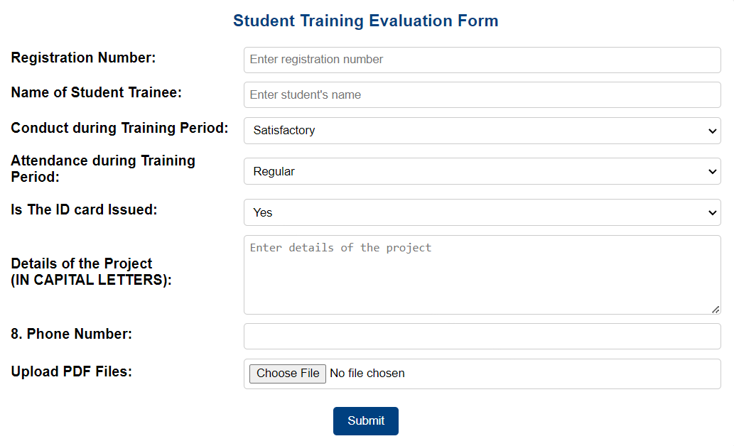
- There is an option to upload a file, enabling the operator to upload an offline-filled form for confirmation purposes.
- Once the details are filled the “Submit” button can be clicked to successfully store the details in the database and generate a No dues form. The operator can print or edit the no dues form by using the <print> and <edit> button respectively.
- If there is no student found in the database it redirects to home page with an error message “Student not found” as shown in the figure.


Generate Certificate
- After filling out the No Dues Form, the Operator should ensure that the student collects their certificate. To facilitate this, there is a link in the sidebar labelled "Generate Certificate." Clicking on this link will redirect the operator to a dedicated window shown below where they can generate and issue the certificate to the student.
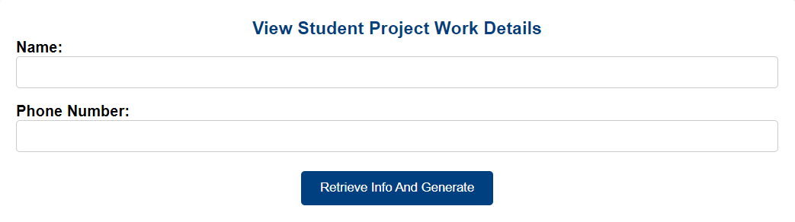
After entering the student name and the phone number of the student, the “retrieve info and generate” button is to be clicked in order to generate his/her certificate.
If the student exists in the database then his/her certificate is generated or else the page is reloaded displaying an error message “Student not found. Please check the details.” as shown below

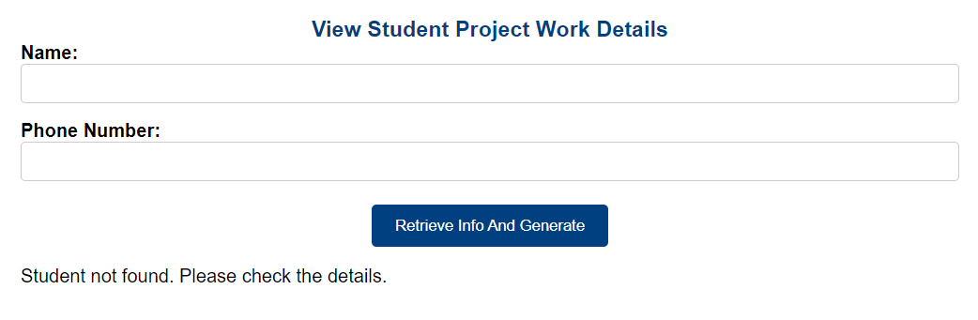
The operator can use this window to re-enter the details and generate the certificate.

- After the certificate is successfully generated, the Operator has the option to print the certificate using the <Print> button. Before printing, the operator must ensure that the "Mark as Collected" checkbox below the print button is checked. This step ensures that a student collects their certificate only once. If the certificate is needed again, the student must contact the Admin for reissue, preventing multiple prints of the same certificate.
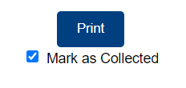

Admin Tasks (Sidebar links)

Create User

The Admin can create new users, whether they are admins or operators, by clicking on the "Create User" section in the sidebar. This will redirect the admin to the following window

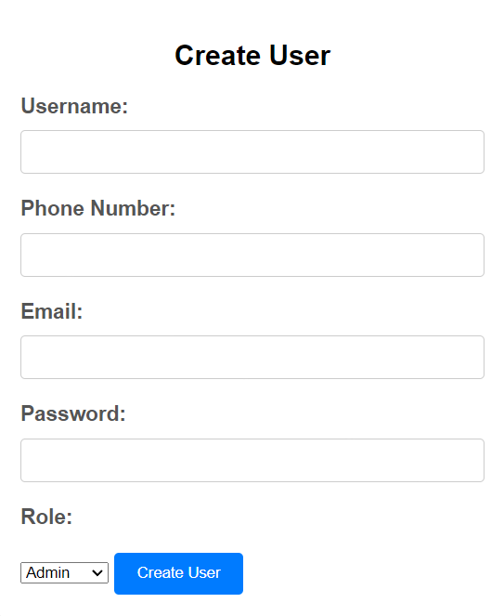

After filling the necessary details the <Create user> button shall be clicked, which will add the new user to the database and redirect the admin to the home page displaying success message as “User Successfully created”.

If the username already exists in the database then the admin will be redirected to the home page displaying an error message “This username is taken”.

Operator Details

The Admin can view the details of all operators by clicking on the "Operator Details" section in the sidebar.

Fetch student internship data

The Admin can retrieve student details for a specific date range by using the "Fetch Student Internship Data" section in the sidebar.

When clicked on "Fetch Student Internship Data" section the screen shown below will be opened in a new window.

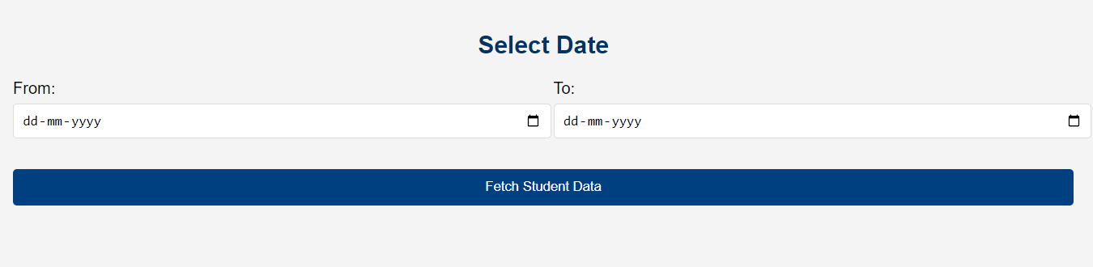

Here, the admin can select a range and then click on “Fetch Student Data” to get the details of the students who have done the internship at ECIL in between that range.

Fetch mentor acceptance forms

The Admin can fetch the details of the mentor acceptance forms submitted by students on a specific date by clicking on the "Fetch Mentor Acceptance Forms" section in the sidebar.

When clicked on "Fetch Mentor Acceptance Forms" section, this screen the screen shown below is opened

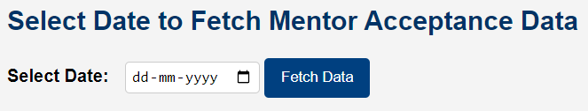

After selecting a date the admin can click on <Fetch data> to get the mentor acceptance form details of the students along with the file if they have uploaded it.

If there is no student found on that date, the admin is redirect to the page shown below with an error message “No data found for the selected date”. Admin can use the page to re-enter the details and fetch again.

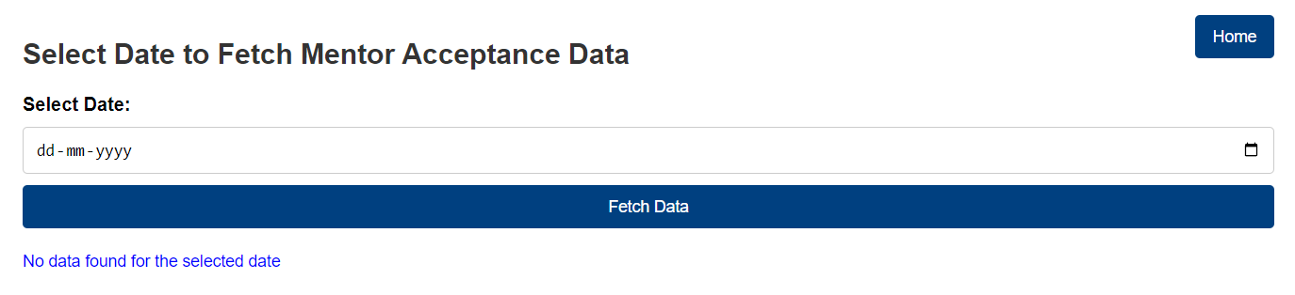

Certificates not collected

The Admin can view the list of students who have not yet collected their certificates by clicking on the "Certificates Not Collected" section in the sidebar.

Internship verifiation

The Admin can verify whether a student has genuinely completed their internship and also view the student's certificate by clicking on the "Internship Verification" section in the sidebar.

Clicking on the "Internship Verification" section will redirect the admin to the screen shown below

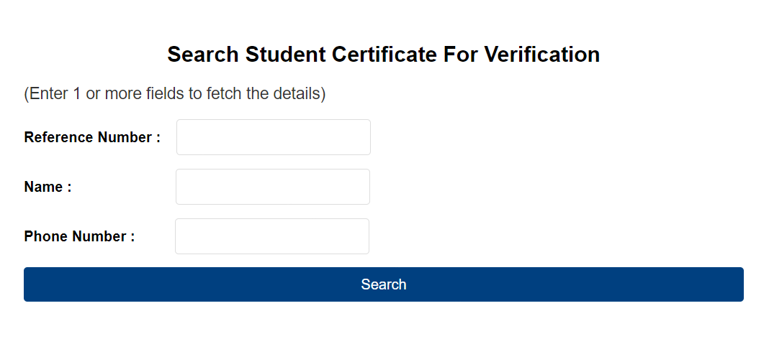

Here, the admin can enter 1 or more fields and click on <search> button to fetch the details of the students.
Partial names can also be used to fetch the results of students with matching names, making it easier to search for and identify records efficiently.
If the student has already collected his certificate then the certificate can be viewed by clicking on “view certificate” link as shown in the figure below
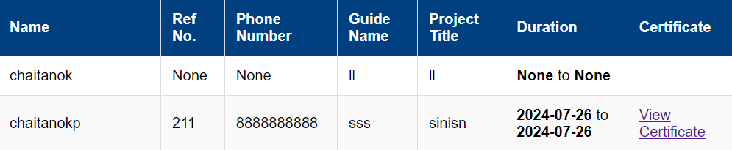

SIP Installation

Contents of SIP
- Static Folder
- Templates Folder
- Studentinternportal.sql file
- Requirements.txt file
- Stuint.py python file
- README.md file

Installation of the required files
- Install Python
- Install MySQL server and MySQL workbench (Set password = 2612)
- Install requirements.txt file by running the following command in the terminal.
>> Pip install -r requirements.txt

Setting up the Database
- Create new connection with name “stuint” with the default port 3306 in MySQL Workbench.
- Click on the connection to open the connection tab and then click on Server>>Data Import as shown in the figure.
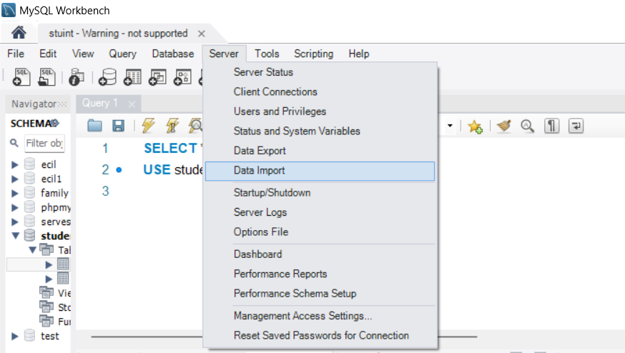

After clicking on data import click on the radio button “import from self contained file” and select “studentinternportal.sql” file as shown below.
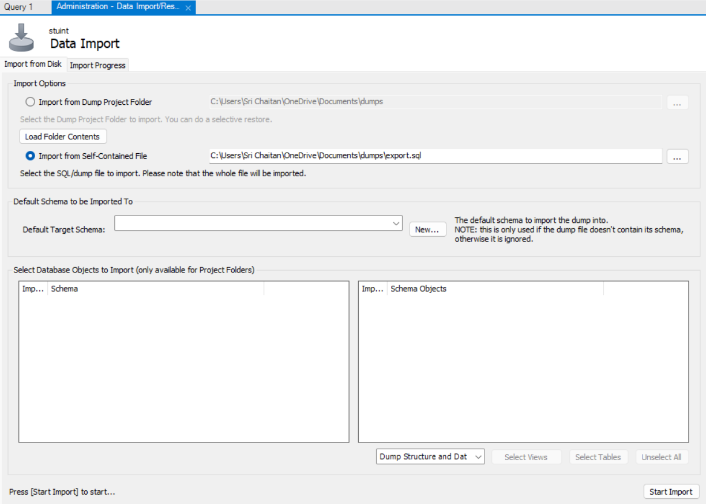
Click on <start import> to import the database.

Running the SIP software

- Go to the dist folder and click on “stuint.exe” to run the sip software (if exe file is provided).
- If you downloaded the code from Github then follow these steps.
- Open a new terminal in the folder where the stuint.py file is located.
- Run “stuint.py” file by using this command in the terminal.
>> python stuint.py

